SORU HAVUZU

UNIT 5

Read the text and complete the table with the correct information from the text. (E10.5.R1.)

The Wonders of Anatolia Route
This 5-day trip covers some of Türkiye's most beautiful historical sites. We start our journey in İstanbul, the exotic old city. On Day 2, we leave İstanbul and drive south along the Aegean coast to the ancient city of Troy in Çanakkale. On Day 3, we continue down the coast to visit the ruins of Ephesus and the Temple of Artemis in İzmir. Next, on Day 4, we head east to Denizli to walk over the magnificent white calcium terraces of Pamukkale. Finally, on Day 5, we drive further east to our last destination, Nevşehir, to see the open-air museum.

Day | Direction Travelled | Destination City | Landmarks / Attractions
Day 2 | South | 1. | 2.
Day 3 | Down the coast | 3. | Ephesus and the Temple of Artemis
Day 4 | 4. | Denizli | 5.
Day 5 | 6. | 7. | 8.

Read the text and write the names under the correct pictures. (E10.5.R2.)

Last summer, four friends chose very different holidays.
Emma spent a week in Antalya. She stayed at a beach resort, swam in the sea every day, and enjoyed traditional Turkish cuisine at seaside restaurants. She also relaxed in a Turkish bath.
Daniel travelled to Rome. He visited historical landmarks such as the Colosseum and the Vatican Museum. He joined guided tours and learned about ancient architecture.
Sophie went to Norway. She hiked in the mountains, explored national parks, and took photos of waterfalls. She said it was the most breathtaking scenery she had ever seen.
Leo preferred something more exciting. He travelled to Costa Rica and tried zip-lining and white-water rafting. He described it as a thrilling and unforgettable experience.




1. ................................... 2. ................................... 3. ................................... 4. ...................................

Write an e-mail to your friend about what you have done and haven’t done on your holidays so far. Use the guiding questions to help you. Write at least 4 sentences. (K.E10.5.W1)

Guiding Questions
  - Where have you spent your holiday so far?
  - What activities have you done during your holiday?
  - What activities haven’t you done yet?
  - Who have you been with?
  - How have you felt about your holiday?

Create your own travel brochure for your favorite city by answering the questions below. Write one sentence for each category. (K.E10.5.W2)
- Where can you stay? - How can you travel around the city?
- What are the traditional dishes? - Which historic places can you see?




City Name: ..................................................
a. Accommodation
b. Transportation
c. Traditional Dishes
d. Historic Sites

UNIT 6

Read the text and answer the questions. (E10.6.R1.)

Online Class Reminder – Student Council
Dear students,
Please remember that you must attend your online lessons on time. You should use polite language in the chat.
Students mustn’t send off-topic messages during the lesson. You had better check your Internet connection before class.
If you ignore these rules, you may miss important information. Let’s create a respectful online environment together!

- What must students do before class? .........................................................................................................

- What kind of language should students use? .............................................................................................

- What is forbidden during lessons? .............................................................................................................

- What may happen if students ignore the rules? .........................................................................................

- Read the conversation and answer the questions. (E10.6.R1.) Lena: Our school is using too much electricity these days.
Mark: What should we do about it?
Lena: I think students should switch off the lights when they leave the classroom. Mark: Yes, and they mustn’t leave computers on during breaks. That’s a school rule. Lena: We had better unplug phone chargers when they are not in use.
Mark: Teachers say we must follow the energy-saving policy. Lena: If we waste electricity, the school will pay higher bills. Mark: Then everyone should act more responsibly.
- What problem does Lena mention? .........................................................................................................

- What is the consequence of wasting electricity? ......................................................................................

- What does Lena advise students to do when leaving the classroom? ......................................................
.......................................................................

3A. Read the Student Netiquette Guide and answer the questions. (E10.6.R1.)
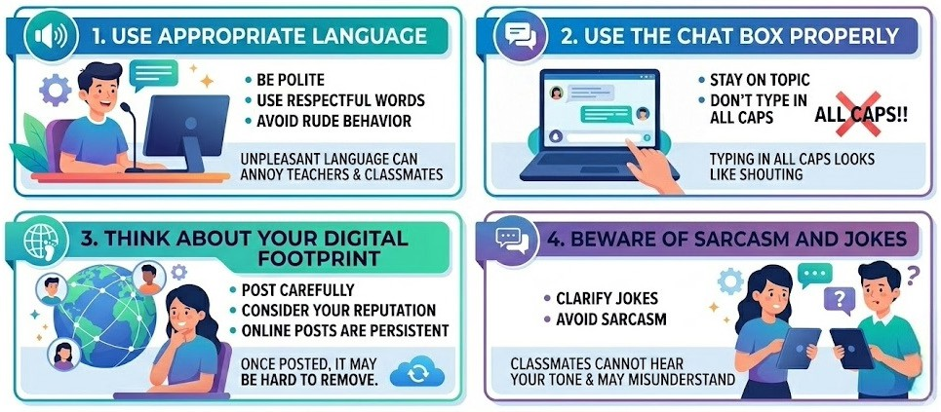
•
•
Typing all caps looks like shouting.
- Post carefully
- Consider your reputation
- Posts are persistent
Once posted, it may be hard to remove.
Stay on topic
Don’t type in all CAPS
Unpleasant language
can annoy other people.
- Be polite
- Use respectful words
- Avoid rude behavior
Classmates may
misunderstand.
- Clarify jokes
- Avoid sarcasm

  - What kind of words should you use online? ...............................................................................................

  - What happens if you post something online? .............................................................................................

  - Why shouldn’t students type in all CAPS? ..................................................................................................

  - Why should you avoid sarcasm and jokes? ................................................................................................

(Bu afiş için 2 tür soru hazırladım. Hangisini isterseniz onu seçebilirsiniz.)

3B. Read the Student Netiquette Guide and complete the sentences. (E10.6.R1.)
    - You be polite and use appropriate language.
    - Students send off-topic messages or type in all CAPS in the chat box.
    - You had better think twice before you photos or comments on the Internet.
    - Students should use polite and language in online communication.
    - If you use rude language, you may .......................................................... .

4A. Read the text. Complete the cause–effect table using information from the text. (E10.6.R2.) (Bu text için 3 tür soru hazırladım. Hangisini isterseniz onu seçebilirsiniz.)
Household chores don't have to be a nightmare. Here are some tips to survive them:

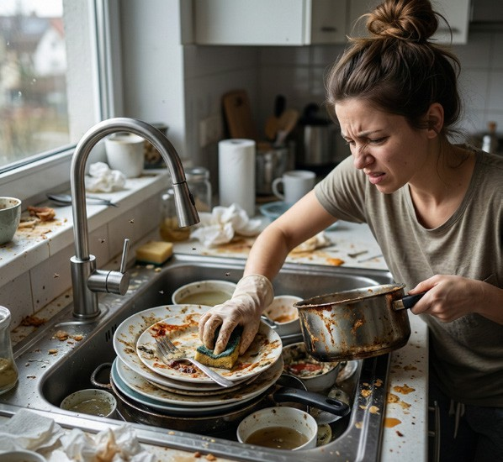

Tip 1: Add some joy!
You should put on your headphones and pump up the music. If you listen to upbeat music, a boring task like tidying up the room will feel much faster and more fun.
Tip 2: Help others!
Look for ways to help elderly neighbours with heavy tasks like taking out the garbage. If you help someone, you will feel proud and happy when they smile thankfully at you.
Tip 3: Don't ignore them!
You must do your chores regularly. If you leave the dishes in the sink for days, the kitchen will smell bad, and it will take twice as much time to clean it later.

Situation | Immediate Result
Listening to upbeat music | a.
Helping elderly neighbours | b.
Leaving dishes for days | c.

4B. Read the sentences from the text and identify their function. (E10.6.R2.)
Write: A = Advice O = Obligation C = Consequence
- You should put on your headphones. ( )
- You must do your chores regularly. ( )
- The kitchen will smell bad. ( )
- It will take twice as much time. ( )
- Look for ways to help elderly neighbours. ( )

4C. Read the text and complete the sentences. (E10.6.R2.)
a regularly prevents unpleasant smells in the kitchen.
b makes the task feel faster and more enjoyable.
c in the sink makes the kitchen unhygienic.
d to housework makes it feel less stressful.
e neighbors creates positive feelings.

Write the possible consequences by completing the sentences below. (E10.6.W1.)

(İstediğiniz kadarını seçebilirsiniz.)

- If you arrive late to school in the morning, ............................................................................................. .
- If you have a toothache, ........................................................................................................................ .
- If students use their mobile phones in class, ........................................................................................ .
- If you want a clean and healthy world, ................................................................................................. .
- If you want to stay healthy, ................................................................................................................... .
- If you have an upset stomach, ............................................................................................................. .
- If we don’t use our energy sources wisely, ........................................................................................... .
- If students run in the school corridors, .................................................................................................. .
- If you want to protect the environment, ................................................................................................. .
- If students don’t wear uniforms, ........................................................................................................... .
- If you want to get a higher grade, ........................................................................................................ .
- If you want to improve your English, ................................................................................................... .
- If students don’t come to class prepared, ........................................................................................... .

- Read Daisy’s problem and write a messagegiving advice to her. Write at least three sentences. (E10.6.W2.)

I am really worried about my school life. I spend hours scrolling through social media, especially late at night. Because of this, I can’t sleep well, and I always feel extremely tired the next day.
I cannot concentrate on my classes, and I keep missing my assignment deadlines.
What should I do? Daisy
Dear Daisy,

UNIT 7

Read the text and complete the table below. (E10.7.R1.)
Let's discover some delicious tastes from different countries!
Turkish cuisine is known for being both healthy and delicious. Kebabs are the most popular dishes in this culture. In this cooking style, meat is usually cooked directly over a fire. The dishes are primarily prepared with simple ingredients. Red pepper, bulgur, beef, and red lentils are the most commonly used ingredients.
Indian cuisine is known for its rich spices and colourful dishes. The most common ingredients are rice, lentils, chicken, coriander, and cumin. Many dishes are cooked with curry and different spice mixtures. Biryani and butter chicken are popular traditional meals.
French cuisine is known for its elegance. It usually includes cheese, cream, butter, and mushrooms. Croissants and onion soup are famous dishes. Many French dishes are baked to enhance their flavour.
There are so many wonderful tastes to discover around the world!

 | Popular Dishes | Main Ingredients | Cooking Methods
Turkish Cuisine | 1. | 2. | 3.
Indian Cuisine | 4. | 5. | Cooked with curry and different spice mixtures
French Cuisine | 6. | 7. | 8.

Read the text and complete the table below. (E10.7.R2.)
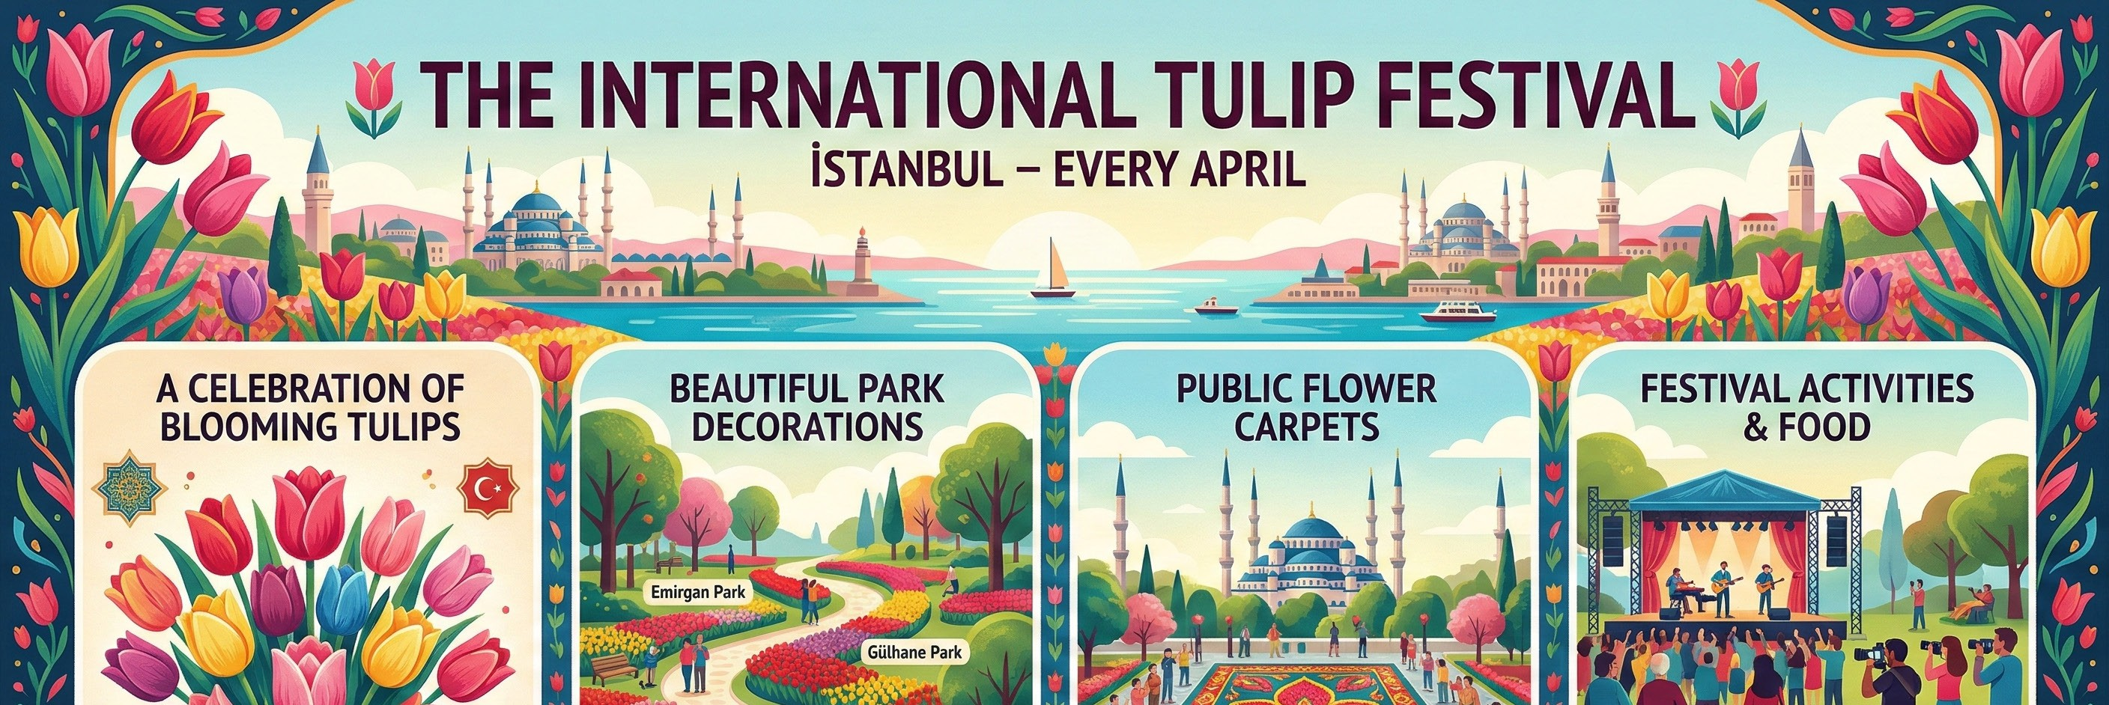
The International Tulip Festival is held in İstanbul every April. It celebrates the blooming of tulips, which are an important symbol of Turkish culture.
During the festival, parks are decorated with colourful tulips. Flower carpets are displayed in public squares. Concerts are performed in open areas, and photography competitions are organized.
Traditional Turkish food is served in festival areas. Special tulip-shaped desserts are prepared for visitors.

Name of the Event | Location (City) | Date / Season | Main Purpose | Food & Drink
1. | 2. | 3. | 4. | 5.

- Read the festival brochure and answer the questions. (E10.7.R2.)



ALAÇATI HERB FESTIVAL
Discover the Taste of Spring in Türkiye!
Location: Alaçatı, İzmir
Time: Every year in April (4-Day Festival)
Purpose: To celebrate local herbs and promote healthy traditional cuisine
Main Events & Highlights
- Local herbs are displayed and sold in street markets.
- Cooking competitions are organized by famous chefs.
- Traditional Aegean dishes are prepared with fresh herbs.
  - What is the name of the festival? .......................................................................................
  - When is it held? .................................................................................................................
  - Where is it celebrated? .......................................................................................................
  - Why do people celebrate it? ...............................................................................................

Write down 4 sentences about your favourite festival by answering the questions below. (K.E10.7.W1.)

Guiding Questions
- Name: What is the festival called?
- Time: When is it held?
- Place: Where is it celebrated?
- Activity: What do people do?
- Reason: Why do people celebrate it?
- Feeling: How do people feel?
- ..................................................................................................

- ..................................................................................................

- ..................................................................................................

- ..................................................................................................

