2025-2026 Anatolian High School 10th Grade 2nd Term 1st Written Exam
Name – Surname: Class: Number:

- Read the text and answer the questions. (3x5=15)

Online Class Reminder – Student Council
Dear students,
Please remember that you must attend your online lessons on time. You should use polite language in the chat.
Students mustn’t send off-topic messages during the lesson.
You had better check your Internet connection before class.
If you ignore these rules, you may miss important information. Let’s create a respectful online environment together!

  - What must students do before class? .........................................................................................................

  - What kind of language should students use? .............................................................................................

  - What is forbidden during lessons? .............................................................................................................

- Read the text. Complete the cause–effect table using information from the text. (3X7=21)

Household chores don't have to be a nightmare. Here are some tips to survive them:

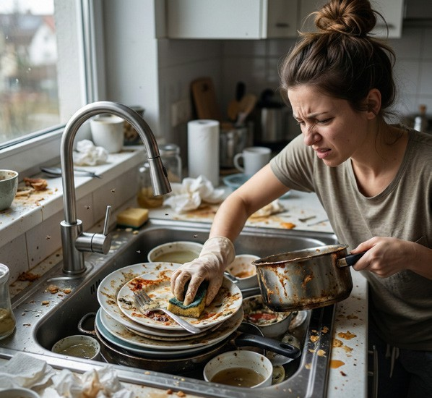

Tip 1: Add some joy!
You should put on your headphones and pump up the music. If you listen to upbeat music, a boring task like tidying up the room will feel much faster and more fun.
Tip 2: Help others!
Look for ways to help elderly neighbours with heavy tasks like taking out the garbage. If you help someone, you will feel proud and happy when they smile thankfully at you.
Tip 3: Don't ignore them!
You must do your chores regularly. If you leave the dishes in the sink for days, the kitchen will smell bad, and it will take twice as much time to clean it later.

Situation | Immediate Result
Listening to upbeat music | a.
Helping elderly neighbours | b.
Leaving dishes for days | c.

- Write the possible consequences by completing the sentences below. (5x4=20)
  - If you have a toothache, ........................................................................................................................ .
  - If you want a clean and healthy world, ................................................................................................. .
  - If you want to stay healthy, ................................................................................................................... .
  - If you want to protect the environment, ................................................................................................. .
  - If you want to get a higher grade, ......................................................................................................... .

- Read the text and complete the table below. (8x3=24)
Let's discover some delicious tastes from different countries!
Turkish cuisine is known for being both healthy and delicious. Kebabs are the most popular dishes in this culture. In this cooking style, meat is usually cooked directly over a fire. The dishes are primarily prepared with simple ingredients. Red pepper, bulgur, beef, and red lentils are the most commonly used ingredients.
Indian cuisine is known for its rich spices and colourful dishes. The most common ingredients are rice, lentils, chicken, coriander, and cumin. Many dishes are cooked with curry and different spice mixtures. Biryani and butter chicken are popular traditional meals.
French cuisine is known for its elegance. It usually includes cheese, cream, butter, and mushrooms.
Croissants and onion soup are famous dishes. Many French dishes are baked to enhance their flavour. There are so many wonderful tastes to discover around the world!
 | Popular Dishes | Main Ingredients | Cooking Methods
Turkish Cuisine | 1. | 2. | 3.
Indian Cuisine | 4. | 5. | Cooked with curry and  different spice mixtures
French Cuisine | 6. | 7. | 8.

- Read the festival brochure and answer the questions. (4x5=20)


ALAÇATI HERB FESTIVAL
Discover the Taste of Spring in Türkiye!
Location: Alaçatı, İzmir
Time: Every year in April (4-Day Festival)
Purpose: To celebrate local herbs and promote healthy traditional cuisine
Main Events & Highlights
- Local herbs are displayed and sold in street markets.
- Cooking competitions are organized by famous chefs.
- Traditional Aegean dishes are prepared with fresh herbs.
- What is the name of the festival? .......................................................................................
- When is it held? .................................................................................................................
- Where is it celebrated? .......................................................................................................
- Why do people celebrate it? ...............................................................................................

