2025-2026 School 11th Grades 1st Term 1st Listening Exam
Name – Surname: Class: Number:

Listening 1 - Listen to the phone conversation and fill in the blanks. (K.E11.1.L1) (8x5=40pts)

Sophia Evans: Good afternoon. May I speak to Mr. Andrew Miller, please?
Mr. Miller: Speaking. (1)?
Sophia Evans: This is Sophia Evans. I’ve applied for the (2) position at your
company. I received an e-mail asking me to call and arrange an interview.
Mr. Miller: Yes, Ms. Evans. Thank you for calling. Would it be possible for you to come in next Thursday?
Sophia Evans: That sounds good. What time would you suggest?
Mr. Miller: (3) 10:30 a.m.?
Sophia Evans: I’m afraid I can’t make it then. I have a (4) presentation that
morning. Could we schedule it for the afternoon instead?
Mr. Miller: Let me see… Yes, I’m (5) at 3 p.m. on Thursday. Would that be okay
for you?
Sophia Evans: Yes, that’s perfect. Thank you!
Mr. Miller: Great. So your (6) is set for Thursday, 21st of March, at 3 p.m. at our
main office on Green Street.
Sophia Evans: Wonderful. Thank you very much, Mr. Miller.
Mr. Miller: You’re welcome, Ms. Evans. Please bring your portfolio and a copy of (7).
Sophia Evans: Of course. I’ll bring both.
Mr. Miller: Excellent. I look forward to (8) you.
Sophia Evans: Likewise. Have a nice day!
Mr. Miller: You too. Goodbye.


Listening 2 - Listen to the dialogue between Daisy and Philip. Write their names under the correct pictures according to their interests. (K.E11.2.L1) (10x6=60pts)
5


1
2
3
4


..........................
10
..........................
..........................
..........................
..........................

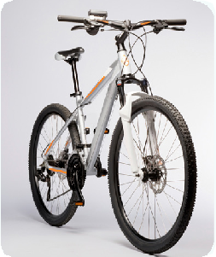
6
7
8
9

..........................
..........................
..........................
..........................
..........................

