SORU HAVUZU

UNIT 5

Read the speeches and complete the statements with the correct names. (K.E11.5.R1)
Jack: I was always busy with work and friends, so I rarely visited my parents.
Sue: I didn’t exercise or eat healthy food. Now I have some health problems.
Tim: I didn’t study for my Maths quiz because I played online games all night. I failed the quiz.
Rose: I forgot to take my umbrella this morning, and it rained. I got completely wet!
Martin: I was very late for school today because I didn’t wake up when my alarm rang.
Mary: I ate too many candies at the party, and now my stomach hurts.

- wishes s/he had taken better care of her/his health.
- regrets her/his eating choices at a social event.
- wishes s/he had checked the weather forecast.
- regrets not spending more time with her/his family.
- wishes s/he had gone to bed earlier last night.
- wishes s/he had prepared better for a school exam.

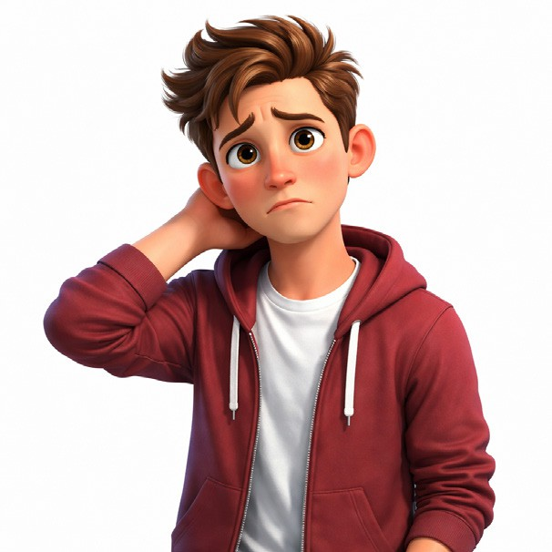
Read Paul’s thought bubbles and write his wishes using the words given. (K.E11.5.W1)

"I can't speak French fluently." "I didn't finish my homework on time."

“I don’t earn enough money.” “I argued with my best friend.”

"I have a small car." “I spent too much time playing games.”

Present Wishes
  - speak / French fluently
Paul wishes ...........................................................
..............................................................................
  - earn / more money
Paul wishes ...........................................................
..............................................................................
  - have / a big car
Paul wishes ...........................................................
...............................................................................

Past Regret
  - finish / his homework / on time
Paul wishes ..............................................................
..................................................................................
  - not argue / with his best friend
Paul wishes ..............................................................
..................................................................................
  - not spend / so much time playing games
Paul wishes ..............................................................
..................................................................................

Read people’s regrets and answer the questions. (K.E11.5.R1)
Topic: #MyBiggestRegret
Susan_99: I wish I hadn’t quit taking piano lessons when I was ten. I thought it was boring back then. If I had continued practicing, I could have played in the school orchestra!
Michael_B: My biggest regret is my careless driving last year. If I had driven below the speed limit, I wouldn’t have crashed my father’s car. If only I had listened to his warnings about safety.
Nancy_Stars: I wish I had saved a portion of my allowance every week. I spent all my money on clothes I never wore. If I hadn’t been so irresponsible with my cash, I would have had enough to buy a ticket to the summer festival.
www.ourregrets.com
- What did Susan quit when she was ten?
.............................................................................................................................
- Who regrets a financial mistake?
.............................................................................................................................
- What would have happened if Michael had driven slowly?
.............................................................................................................................
- What would Nancy have bought if she had saved her money?
.............................................................................................................................
- Who regrets a decision about a hobby?
.............................................................................................................................

Read the speech bubbles and make sentences as in the example. (K.E11.5.W1)






Chloe: I didn’t set an alarm last night, so I woke up late for school.

Ryan: I didn’t save my document, so I lost all my work.

Lily: I didn’t study regularly, so I failed the final exam.

Ethan: I didn’t practice enough for the match, so I played badly.

Mia: I didn’t charge my phone, so it turned off during the trip.

Example: Chloe: If I had set an alarm last night, I wouldn’t have woken up late for school.
  - Ryan: .............................................................................................................................
  - Lily: ................................................................................................................................
  - Ethan: .............................................................................................................................
  - Mia: ................................................................................................................................

UNIT 6

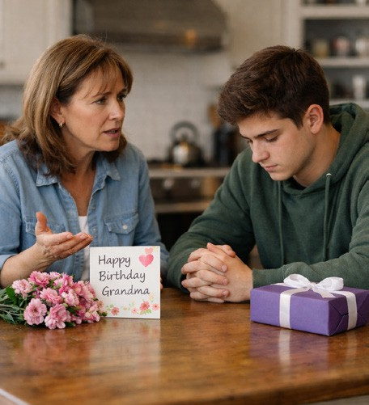
- Read the dialogue and answer the questions. (K.E11.6.R1) Mother: I’m very upset. You didn’t visit your grandma yesterday.
Tom: I know… I should have called her.
Mother: She was waiting for you all day. You shouldn’t have forgotten about her birthday.
Tom: I could have been more responsible. I feel terrible now.
Mother: You must have hurt her feelings.
Tom: I’ll apologize today.
- Why is the mother upset? ........................................................................................
- How does Tom feel? ................................................................................................
- What mistake did Tom make? ..................................................................................
- What will Tom do now? ............................................................................................

Read Emma’s mistakes. Write a sentence using "She should / shouldn't have..." (K.E11.6.R1)
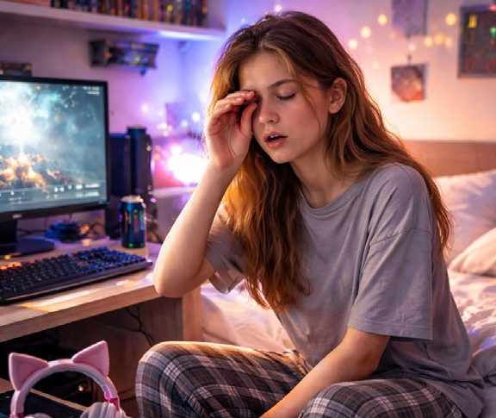
Emma is usually a very hardworking student. However, yesterday she made a terrible mistake. Emma is very sad today. She got a bad grade on her English test. Last night, she had a lot of homework, but she didn’t do it. Instead, she played video games for three hours and went to bed very late. She fell asleep during the test today! Now, Emma regrets her choices. She promises to study harder for the next exam. She knows that video games can wait until the weekend.
- Emma (play video games all night)
- Emma (do her homework)
- Emma (study for her English test)
- Emma (go to bed late)
- Emma (be more responsible)

- Read the events and criticise the people. Use should / shouldn’t have + past participle.(K.E11.6.W1) İstediklerinizi seçebilirsiniz.

Lucy missed her job interview.
    - She woke up very late.
…………………………………………………………………………………
    - She didn’t check the address carefully.
…………………………………………………………………………………

Kevin failed his driving test.
    - He didn’t practise enough.
…………………………………………………………………………………
    - He used his phone while driving.
…………………………………………………………………………………

Daniel broke his mother’s vase.
    - He played football inside the house.
…………………………………………………………………………………
    - He didn’t listen to his mother’s warning.
…………………………………………………………………………………

Michael was late for school.
    - He stayed up very late watching TV.
…………………………………………………………………………………
    - He didn’t set his alarm.
…………………………………………………………………………………

Chloe hurt her little sister’s feelings.
    - She shouted at her little sister.
…………………………………………………………………………………
    - She didn’t apologize afterwards.
…………………………………………………………………………………

Emily got a bad grade on her science exam.
    - She didn’t revise regularly.
…………………………………………………………………………………
    - She spent too much time on social media.
…………………………………………………………………………………

Mia got a bad sunburn at the beach.
    - She stayed under the sun for four hours.
...................................................................................................................
    - She didn’t apply sunscreen.
...................................................................................................................

Write a letter of complaint including the given parts in the box according to the situation below. (K.E11.6.W1)
Dear Sir/Madam,

Yours faithfully
Situation: Last Saturday, you attended a concert in your city. However, the event was very disappointing.
- The concert started two hours late.
- The sound system didn’t work properly.
- The security staff were rude.
- The food stalls were overpriced and unhygienic.
- The organizers refused to refund your money.

Introduction: Reason for writing
Main Body: Details of complaints and reasons
Conclusion: Your demand

UNIT 7

Look at the brochure and answer the questions. (K.E11.7.R1)

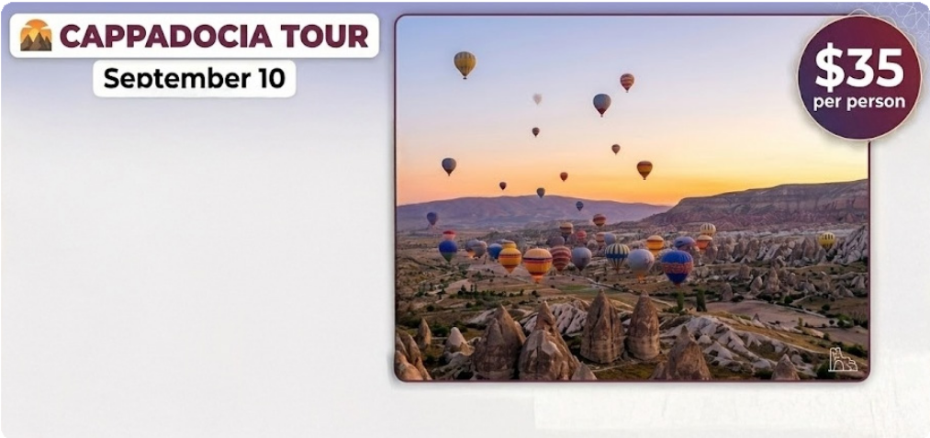
08:30 am and 05:30 pm

Discover the Magic of Cappadocia!
  - Explore the famous fairy chimneys and breathtaking valleys.
  - Visit the Göreme Open-Air Museum, a UNESCO World Heritage Site.
  - Discover the ancient underground cities of Derinkuyu and Kaymaklı.
  - Take an unforgettable hot air balloon ride at sunrise.

Call +90 384 222 33 44 for more details.

- How long does the tour last?

- Is the tour free? If not, how much is it?

- What famous places can visitors see in Cappadocia?

- What can people do to get more information?

Read the text and complete the table. (K.E11.7.R1)
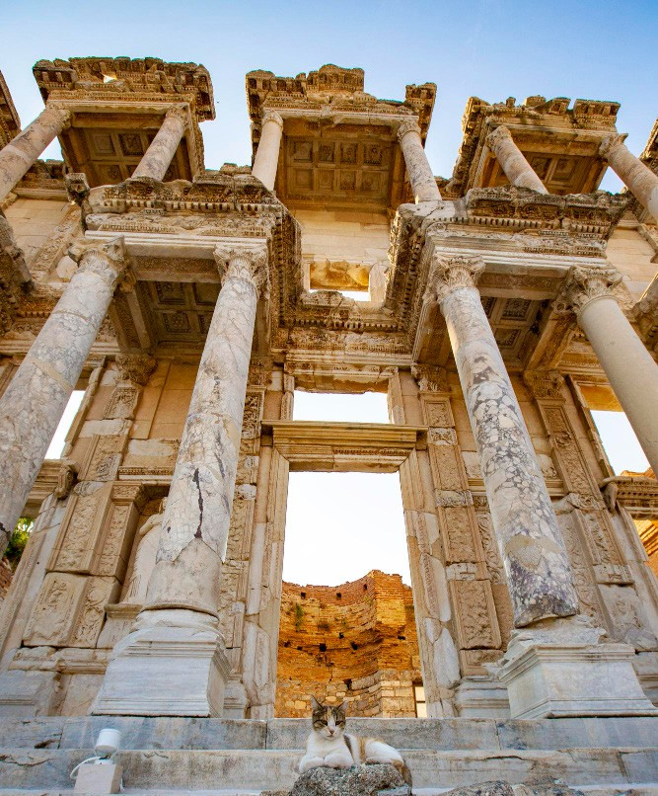
THE ANCIENT CITY OF EPHESUS
Ephesus is located near Selçuk in İzmir, Türkiye. It was founded by the Ancient Greeks in the 10th century BC. It became one of the most important trade centers of the ancient world.
The city was home to many impressive structures. The Temple of Artemis was considered one of the Seven Wonders of the Ancient World. The Great Theater, which could hold more than 24,000 people, was used for performances and public meetings. The Library of Celsus, constructed in 117 AD, was one of the richest libraries of its time.
Ephesus was included in the UNESCO World Heritage List in 2015. Today, it attracts millions of visitors every year because of its well-preserved ruins and great historical value.

Location | Age / Date | Significance | UNESCO Status | Builders
1. | 2. | 3. | 4. | 5.

Read the text and complete the table. (K.E11.7.R1) THE IMPERIAL RESIDENCE: TOPKAPI PALACE
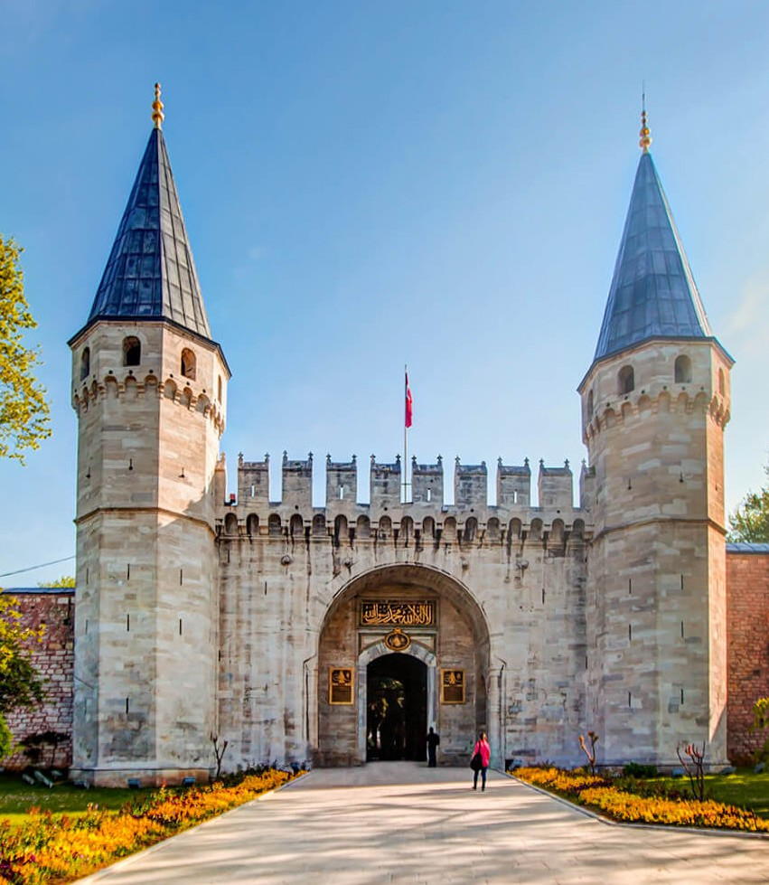
Topkapı Palace is one of the most important historical monuments in Türkiye. It is located in the Sarayburnu district of Istanbul. For centuries, it served as the political center of the Ottoman Empire.
The construction of Topkapı Palace was completed in 1478 by order of Sultan Mehmed II. The palace was the residence of Ottoman sultans for nearly 400 years. It reflects the characteristics of Ottoman architecture.
The palace consists of four main courtyards. Important sections include the Imperial Council Hall, the Harem and the Tower of Justice. After the establishment of the Turkish Republic, Topkapı Palace was turned into a museum in 1924. Today, it is a UNESCO World Heritage Site and attracts millions of visitors every year.
Topkapı Palace is considered a symbol of the power and cultural richness of the Ottoman Empire.

1. the name of the monument
2. the city and district where it is located
3. the sultan who ordered its construction
4. the year the construction was completed
5. the architectural style it reflects
6. the number of main courtyards
7. the year it became a museum
8. what it symbolises today

Imagine that you are a travel blogger! Choose a city and write 5 sentences by answering the guiding questions. Your goal is to recommend, describe, and advise visitors. (K.E11.7.W1)

- Which city have you chosen? Where is it located?
- Why is this city famous?
- What are the must-see attractions in this city?
- Why is this place important for Turkish history?
- Are there any natural beauties?
- When is the best time to visit this city?
- What should visitors definitely do there?
- Why do you think this city is worth seeing?

WELCOME TO MY TRAVEL BLOG

You are a travel blogger writing for an international website called “Discover Türkiye.” Write a blog post of at least 5 sentences recommending a city or a historical site in Türkiye. (K.E11.7.W1)
Your blog post must:
- Describe the location of the place
- Mention at least ONE important landmark or monument
- Include historical information (date, builder, significance, etc.)
- Describe cultural or natural attractions
- Give advice to visitors
- Clearly recommend the place
WELCOME TO MY TRAVEL BLOG

