2025-2026 Anatolian High School 11th Grade 2nd Term 1st Written Exam
Name – Surname: Class: Number:

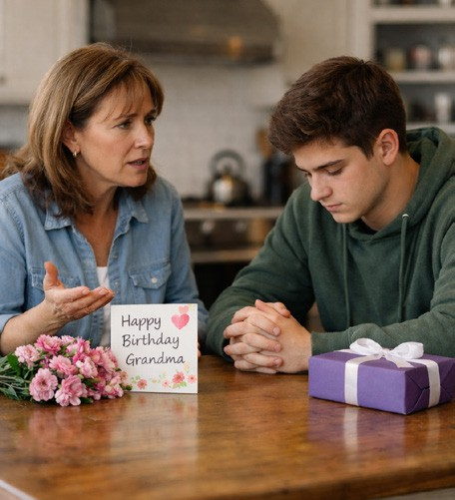
- Read the dialogue and answer the questions. (4x5=20) Mother: I’m very upset. You didn’t visit your grandma yesterday.
Tom: I know… I should have called her.
Mother: She was waiting for you all day. You shouldn’t have forgotten about her birthday.
Tom: I could have been more responsible. I feel terrible now.
Mother: You must have hurt her feelings.
Tom: I’ll apologize today.
- Why is the mother upset? ........................................................................................
- How does Tom feel? ................................................................................................
- What mistake did Tom make? ..................................................................................
- What will Tom do now? ............................................................................................

- Read the events and criticise the people. Use should / shouldn’t have. (8x4=32)

Lucy missed her job interview.
  - She woke up very late.
…………………………………………………………………………………
  - She didn’t check the address carefully.
…………………………………………………………………………………

Daniel broke his mother’s vase.
  - He played football inside the house.
…………………………………………………………………………………
  - He didn’t listen to his mother’s warning.
…………………………………………………………………………………

Michael was late for school.
  - He stayed up very late watching TV.
…………………………………………………………………………………
  - He didn’t set his alarm.
…………………………………………………………………………………

Chloe hurt her little sister’s feelings.
  - She shouted at her little sister.
…………………………………………………………………………………
  - She didn’t apologize afterwards.
…………………………………………………………………………………

Look at the brochure and answer the questions. (4x7=28)

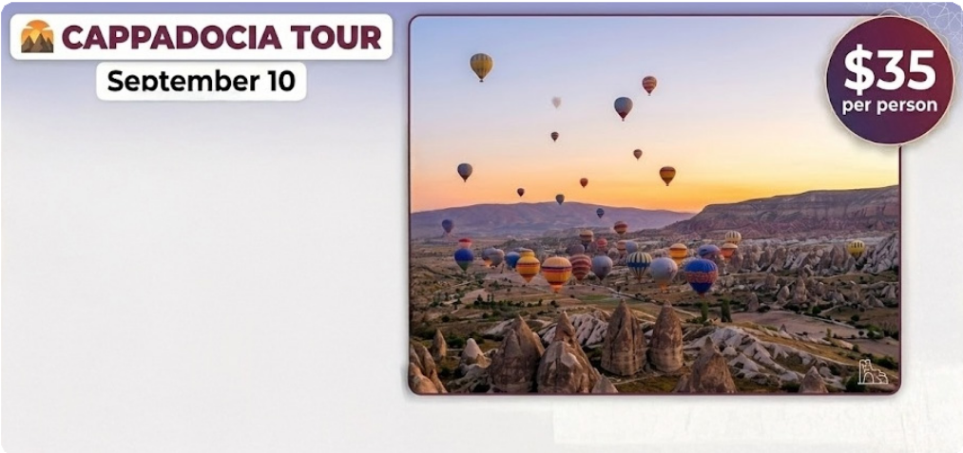
08:30 am and 05:30 pm

Discover the Magic of Cappadocia!
  - Explore the famous fairy chimneys and breathtaking valleys.
  - Visit the Göreme Open-Air Museum, a UNESCO World Heritage Site.
  - Discover the ancient underground cities of Derinkuyu and Kaymaklı.
  - Take an unforgettable hot air balloon ride at sunrise.

Call +90 384 222 33 44 for more details.

- How long does the tour last?

- Is the tour free? If not, how much is it?

- What famous places can visitors see in Cappadocia?

- What can people do to get more information?

Imagine that you are a travel blogger! Choose a city and write 4 sentences by answering the guiding questions. Your goal is to recommend, describe, and advise visitors. (4x5=20)

- Which city have you chosen? Where is it located?
- Why is this city famous?
- What are the must-see attractions in this city?
- Why is this place important for Turkish history?
- Are there any natural beauties?
- When is the best time to visit this city?
- What should visitors definitely do there?
- Why do you think this city is worth seeing?

WELCOME TO MY TRAVEL BLOG

