2025-2026 Anatolian High School 11th Grade 2nd Term 1st Written Exam
Name – Surname: Class: Number:

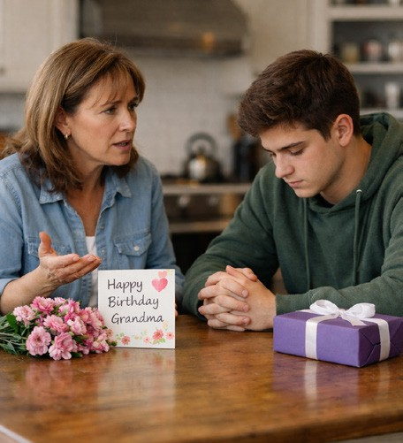
- Read the dialogue and answer the questions. (4x5=20) Mother: I’m very upset. You didn’t visit your grandma yesterday.
Tom: I know… I should have called her.
Mother: She was waiting for you all day. You shouldn’t have forgotten about her birthday.
Tom: I could have been more responsible. I feel terrible now.
Mother: You must have hurt her feelings.
Tom: I’ll apologize today.
- Why is the mother upset? ........................................................................................
- How does Tom feel? ................................................................................................
- What mistake did Tom make? ..................................................................................
- What will Tom do now? ............................................................................................

- Read the events and criticise the people. Use should / shouldn’t have. (8x4=32)

Lucy missed her job interview.
  - She woke up very late.
…………………………………………………………………………………
  - She didn’t check the address carefully.
…………………………………………………………………………………

Daniel broke his mother’s vase.
  - He played football inside the house.
…………………………………………………………………………………
  - He didn’t listen to his mother’s warning.
…………………………………………………………………………………

Michael was late for school.
  - He stayed up very late watching TV.
…………………………………………………………………………………
  - He didn’t set his alarm.
…………………………………………………………………………………

Chloe hurt her little sister’s feelings.
  - She shouted at her little sister.
…………………………………………………………………………………
  - She didn’t apologize afterwards.
…………………………………………………………………………………

Look at the brochure and answer the questions. (4x7=28)

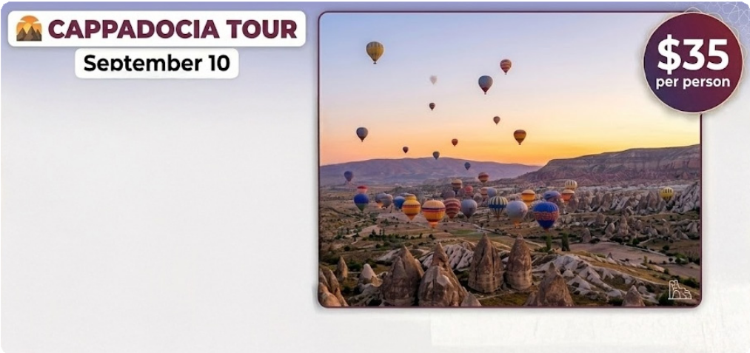
08:30 am and 05:30 pm

Discover the Magic of Cappadocia!
  - Explore the famous fairy chimneys and breathtaking valleys.
  - Visit the Göreme Open-Air Museum, a UNESCO World Heritage Site.
  - Discover the ancient underground cities of Derinkuyu and Kaymaklı.
  - Take an unforgettable hot air balloon ride at sunrise.

Call +90 384 222 33 44 for more details.

- How long does the tour last?

- Is the tour free? If not, how much is it?

- What famous places can visitors see in Cappadocia?

- What can people do to get more information?

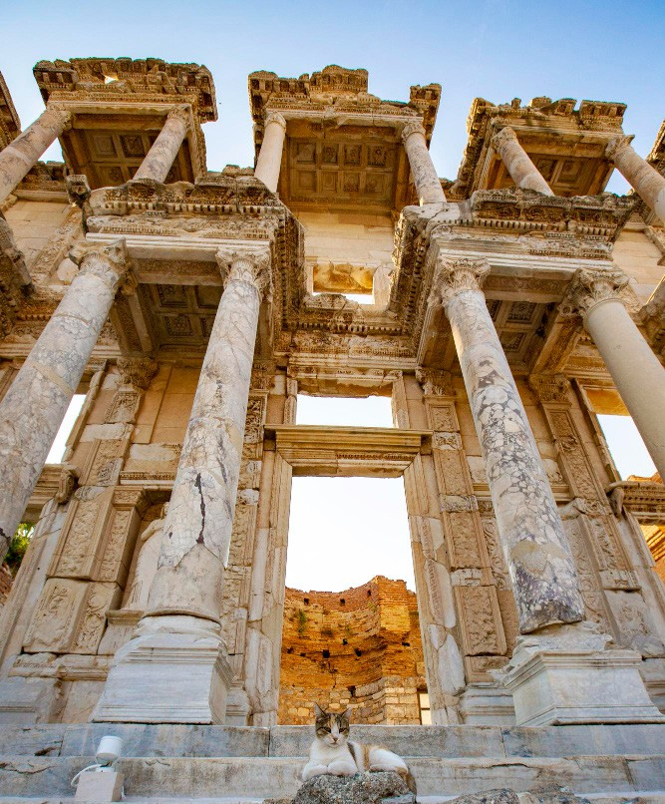
Read the text and complete the table. (5x4=20) THE ANCIENT CITY OF EPHESUS
Ephesus is located near Selçuk in İzmir, Türkiye. It was founded by the Ancient Greeks in the 10th century BC. It became one of the most important trade centers of the ancient world.
The city was home to many impressive structures. The Temple of Artemis was considered one of the Seven Wonders of the Ancient World. The Great Theater, which could hold more than 24,000 people, was used for performances and public meetings. The Library of Celsus, constructed in 117 AD, was one of the richest libraries of its time.
Ephesus was included in the UNESCO World Heritage List in 2015. Today, it attracts millions of visitors every year because of its well-preserved ruins and great historical value.

Location | Age / Date | Significance | UNESCO Status | Builders
1. | 2. | 3. | 4. | 5.

