2025-2026 High School 12th Grades 1st Term 1st Exam (SORU HAVUZU)

UNIT 1

E12.1.R1. Students will be able to infer people’s music preferences from their ideas about music in a reading text.

(Bu kazanım için 2 soru hazırladım. İstediğinizi seçebilirsiniz.)

Question 1. Read the text and answer the questions. (K.E12.1.R1.)

- What type of music does Martin like?
Martin and Jane like different types of music. Martin thinks classical music is calm and helps him relax. He feels peaceful when he listens to it. Jane enjoys pop music because it is fun and makes her happy. She thinks that pop music has fast beats and makes her feel excited.

Music can affect our feelings in different ways. Some use
music to relax, while others use it to feel more energy.
In the end, what matters is how the music makes each person feel. Everyone has their own favorite type of music.

...........................................................................

- Why does Jane enjoy pop music?

...........................................................................

- What are two reasons people listen to music?

...........................................................................

Question 2. Read the text and answer the questions. (K.E12.1.R1.)


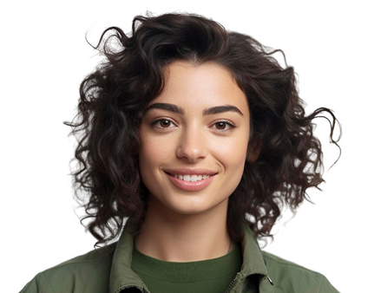
PEOPLE’S MUSIC CHOICES
Sophie
David
Maya
“I love listening to slow and emotional songs. The lyrics are meaningful, and they help me relax after a long day. In my opinion, music should touch
people’s hearts.”
“I enjoy songs with strong rhythm and fast beats. I think they make me feel alive and full of energy. Don’t you think dancing to music is the best way to have fun? My
favorite band is BTS.”
“I like songs that tell stories about life and people. I believe acoustic music is the most
natural and real. According to me, Ed Sheeran is one of the best
songwriters ever.”

- What is the main idea of the text?

.....................................................................................

- What type of music does Sophie prefer?

.....................................................................................
- Why does David listen to fast songs?

.................................................................................

- Who is Maya’s favorite singer?

..................................................................................

E12.1.R2. Students will be able to analyze surveys/interviews to answer related questions.

(Bu kazanım için 2 soru hazırladım. İstediğinizi seçebilirsiniz.)

Question 1. Answer the questions according to the table. (K.E12.1.R2)
Music Preferences of Teenagers

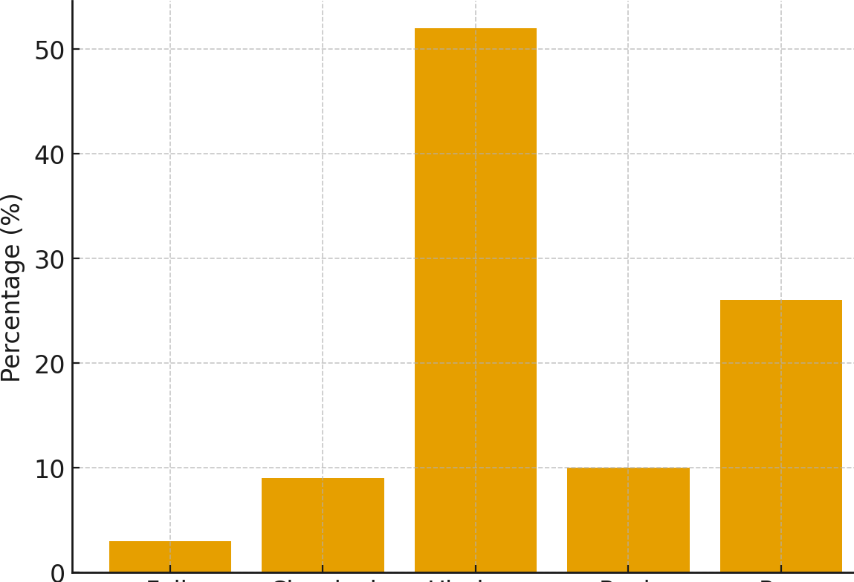
  - What kind of music is the most popular one?

.....................................................................................

  - What kind of music is the least popular one?

.....................................................................................

Folk Classical Hip-Hop Rock Pop
  - How many music styles are shown in the chart?

.....................................................................................

Question 2. Read the survey on music preferences of teenagers and complete the sentences. (K.E12.1.R2)

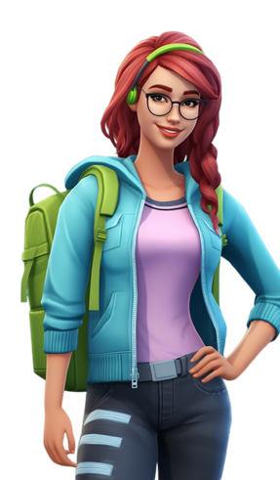

    - The majority of the girls listen to ........................................
Music Types | Boys | Girls
Rock music | % 50 | % 10
Pop music | % 20 | % 65
Folk music | % 25 | % 25
Classical music | %5 | % 0

    - Half of the boys prefer .......................................................

    - None of the girls prefers .....................................................

    - The minority of the boys prefer ..........................................

E12.1.W1. Students will be able to write a survey report on their friends’/teachers’ music preferences.

(Bu kazanım için 2 soru hazırladım. İstediğinizi seçebilirsiniz.)

Question 1. The table below shows music preferences of 100 people. Write down three sentences to compare music preferences using the phrases given. (K.E12.1.W1)

Most of the people .... | The minority of the people .... | The majority of the people ....
None of the people .... | ... of the people .... | The most favorite ....
prefer | like | would rather
Types of Music | Number of People
Rock | 8
Hip-hop | 23
Classical | 16
Pop | 53
Jazz | 0

1. .....................................................................................
2. .....................................................................................
3. .....................................................................................

Question 2. The table below shows the answers of 100 people to the questions. Write down 3
sentences according to their answers using the phrases given. (K.E12.1.W1)

Most of the people .... | The minority of the people .... | The majority of the people .... | like
None of the people .... | ... of the people .... | The most favorite .... | prefer
What kind of music are you interested in?
Classical | Rock | Pop | Hip-hop
4 | 26 | 56 | 14

What makes a song good?
Feeling | Sound | Melody | Lyrics
45 | 12 | 24 | 19

How does music make you feel?
Happy | Relaxed | Energetic | Sleepy
11 | 36 | 50 | 3

How often do you go to concerts?
Never | Sometimes | Rarely | Always
5 | 52 | 12 | 31

- .....................................................................................

- .....................................................................................

- .....................................................................................

UNIT 2

E12.2.R1. Students will be able to find irrelevant content about the descriptions of the people in a text.

(Bu kazanım için 2 soru hazırladım. İstediğinizi seçebilirsiniz.)

Question 1. There is one irrelevant sentence in each paragraph. Read the text and write the irrelevant sentences in each paragraph. (K.E12.2.R1.)
Philip is my brother. He is tall and of average weight. He has short, curly brown hair and green eyes. He prefers classical music to rock. He looks nice and always dresses well. His smile is friendly, and he wears glasses sometimes. Many people notice his bright eyes when they meet him.

Philip’s character is what makes him a great brother. He is respectful and helps me when I need him. He is talkative and very honest, so I trust him. He is also funny and makes me laugh. Everyone enjoys being around him because he is polite. He is also very aggressive.

Paragraph 1: ....................................................................................................................................

Paragraph 2: ....................................................................................................................................

Question 2. Read the texts and identify the irrelevant sentences in each paragraph, providing reasons for each one. (K.E12.2.R1.)

Sophie is in her 30s. She has short, curly, and blonde hair. Her brother plays the guitar in a band. She has green eyes and a big smile. She loves painting in her free time. She is tall and slim.

Jason is a generous and supportive person. He has brown eyes and wavy black hair. His dog is very lazy and sleeps all day. He looks younger than his real age because he always smiles.

Irrelevant sentence:

Reason:
Irrelevant sentence:

Reason:

E12.2.R2. Students will be able to identify the main conclusions in argumentative texts.

(Bu kazanım için 3 soru hazırladım. İstediğinizi seçebilirsiniz.)

Question 1. Read the email and answer the questions. (K.E12.2.R2.)

  - What kind of person is Steve?

Dear Robert,
Let me tell you about my best friend, Steve. We have been good friends since middle school. Steve is 25 years old. He is tall and has short blond hair and green eyes.
Steve is a very friendly and helpful person. He always supports his friends and gives them good advice. He is also honest and always tells the truth, even when it’s not easy.
We go running together, watch football matches, and sometimes cook dinner at the weekends. I’m really glad to have a best friend like Steve.

David

.........................................................................

  - What does Steve look like?

.........................................................................

  - What do David and Steve do together?

.........................................................................

Question 2. Read the text and answer the questions. (K.E12.2.R2.)
Friendship is a special thing. Your friends make you feel happy. They give you unconditional love, which means they love you no matter what. Spending time with friends is fun. You can do many things together.
Some people think true friendship is hard to find today because life is busy. Real friends help each other
and stay together even when life is hard. Social media and events also make it easier to stay in touch.
When you and your friend have things in common, it is easier to get along well with each other. In time, you will have a strong bond with your friend. So, even in today’s busy world, true friendships are strong and can last a long time. True friendship will never disappear.
- What does “unconditional love” mean? ...............................................................................................................

- How do friends make you feel? ...........................................................................................................................

- Will true friendship ever disappear, according to the text? .................................................................................

Question 3. Read the text and answer the questions. (K.E12.2.R2.)


  - Who is sociable?

My name is Brian. I have three close friends. Their names are Lucy, Amy and Philip. Lucy always goes to school on time; she is never late. Amy enjoys meeting new people and is always the
first to talk in a group. Philip always tells the truth. He never tells lies. They are all great friends. I love them.
....................................................
  - Who is honest?
....................................................
  - Who is punctual?
....................................................

E12.2.W1. Students will be able to write an opinion essay about qualities of a good friend by stating reasons.

(Bu kazanım için 1 soru hazırladım. )

Question 1. Write down at least five sentences about qualities of a good friend by stating reasons by answering the questions below. (K.E12.2.W1.)

- What are the three most important qualities of a good friend?
- Is a good friend kind? Why?
- Is a good friend funny? Why or why not?
- Do you like friends who help you? Why?
- Should a good friend listen to you? Why?
- Do you like spending time with your friend? Why?
- What do you and your good friend do together?
- Do you and your friend share things? What do you share?
- Do you trust your friend? Why?
- What do you love most about your best friend?

