SORU HAVUZU

UNIT 5
- Read the text message conversation between two friends and answer the questions. (E12.5.R2.)

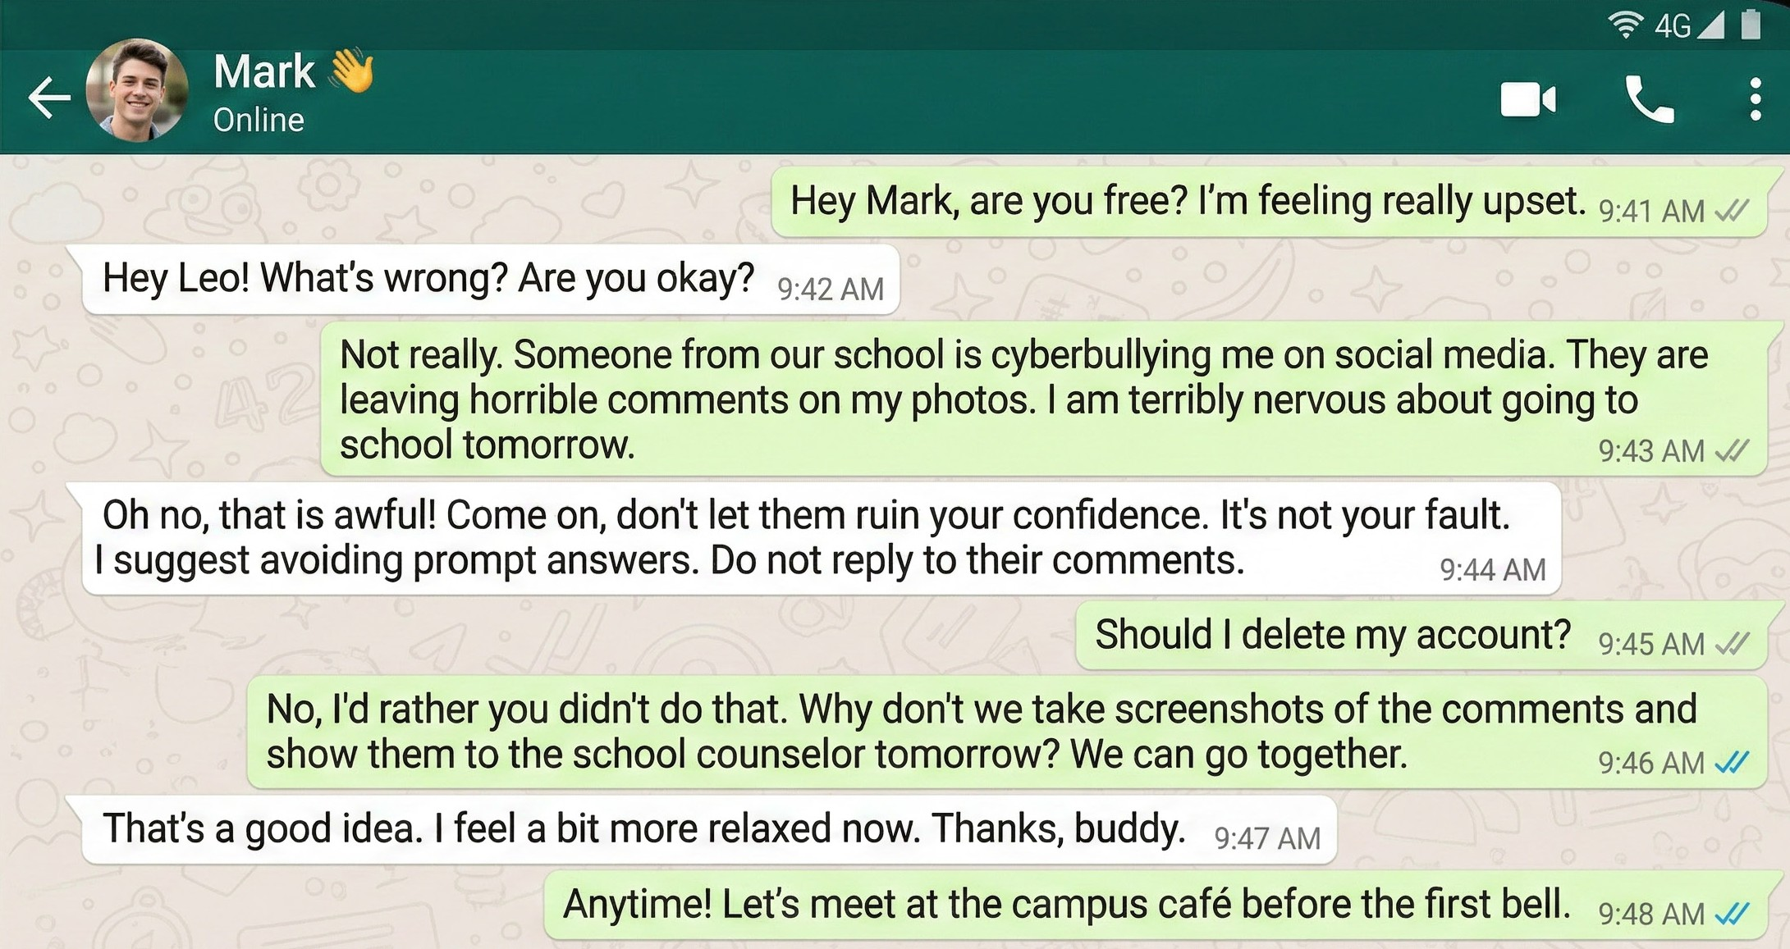
- Why is Leo feeling upset and nervous? ........................................................................................................
- What is Mark's first piece of advice? .............................................................................................................
- Who does Mark suggest they talk to about the problem? .............................................................................
- Where will the two friends meet tomorrow morning? ....................................................................................

- Read the text and answer the questions. (E12.5.R2.)


Did you know that weather conditions can affect your mood?
According to recent research, more serotonin is released in sunny and bright weather. This makes people feel happy and energetic.
However, cloudy and gloomy days cause people to feel moody and lazy.
People living in northern countries with long winters tend to suffer from winter depression more often. On the other hand, those who live in mild climates usually feel more optimistic.
Experts suggest taking regular exercise and developing hobbies to reduce negative effects.
- What hormone is mentioned in the text? ....................................................................................................
- Which type of weather increases happiness? ............................................................................................
- Who suffers from winter depression more often?........................................................................................
- What do experts suggest? ..........................................................................................................................

- Look at the pictures below and describe the mood they create. Answering the guiding questions below may help you. Write at least 4 sentences. (E12.5.W1.)

  - What do you see in the photo?
  - How does it make you feel?
  - What is your current mood?
  - What does it remind you of?

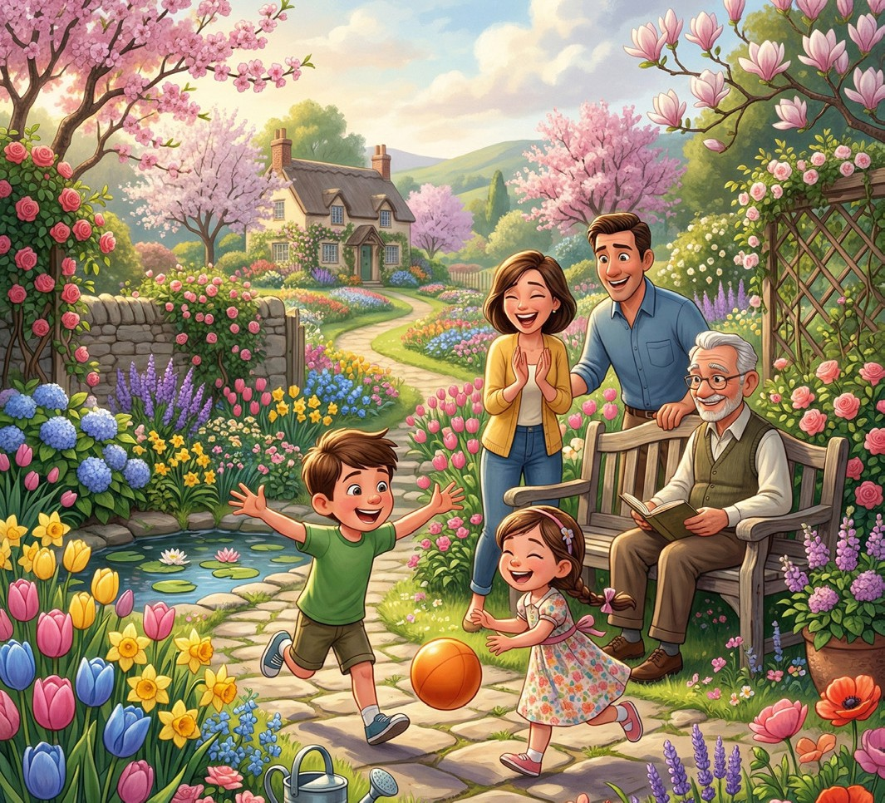
- ..........................................................................................................................
- ..........................................................................................................................
- ..........................................................................................................................
- ..........................................................................................................................

- Answer the questions below about your feelings in different situations. (E12.5.W1.)

- How do you feel before an important exam?
- How do you feel when you get a low grade?
- How do you feel when you argue with a friend?
- How do you feel when you meet new people?
- What do you usually do to clear your mind when you feel stressed?
- How does cloudy weather make you feel?
- How do you feel on a sunny day?
- How does cold weather affect your mood?
- Do you feel more energetic in summer or winter? Why?
- What makes you feel calm and relaxed?

UNIT 6
1A. Read the brochure and complete the phrases with the correct details. (K.E12.6.R1.)


“Plant Today, Breathe Tomorrow”

Green Future Association is an environmental nonprofit organization founded in 2015 in İzmir. The association works to fight climate
change and increase public awareness about environmental protection.

The organization invites everyone to join their Tree Planting Campaign on April 18th at 10:00
a.m. at İnciraltı City Park.
The aim of the campaign is to plant 5,000 trees in one day.

DONATE & SUPPORT

All donations will be used for purchasing seedlings.

- Foundation year : .................................
- Campaign date : ..................................
- Venue : ................................................
- Motto: ..................................................

1B. Read the brochure and answer the questions. (K.E12.6.R1.)
- What is the aim of the campaign? .....................................................................................................
- Where was the association founded? ...............................................................................................
- What will donations be used for? .......................................................................................................

2. Read the brochure and answer the questions. (K.E12.6.R1)


FOUNDATION
Sports for All Foundation was established in 2008 in Amsterdam by former athletes. The organization focuses on providing free sports training for children with disabilities.
The foundation organizes international sports camps every summer and works in cooperation with local schools. More than 1,200 children benefit from its programs each year.
Its mission is to ensure equal access to sports and promote inclusion. Donations are mainly collected through annual charity football matches.
- What is the main mission of the foundation? .........................................................................................
- Which group of children does the foundation support? .........................................................................
- How are donations mainly collected? .....................................................................................................
- Who does the foundation cooperate with? .............................................................................................

- Imagine that you are a member of a charity organization for animal rights. Complete the blanks to invite people to an event of your charity organization. (K.E12.6.W1)



Join Us to .....................................................
Aim of the event: .........................................
.......................................................................

You can contribute by:
- ......................................................
- ......................................................

Date: ...........................................

Place: .........................................

............................................................

- Read the scholarship announcement and write an email in response to it. (K.E12.6.W2)

In your email:
  - Introduce yourself (name, field of study).
  - Explain why you are writing.
  - Mention your academic success.
  - Explain why you need the scholarship.
  - Say why you are a suitable candidate.
  - End your email politely.
Dear Sir/Madam,

UNIT 7
- Read the short story and complete the table. (K.E12.7.R1)

The Lost Boat
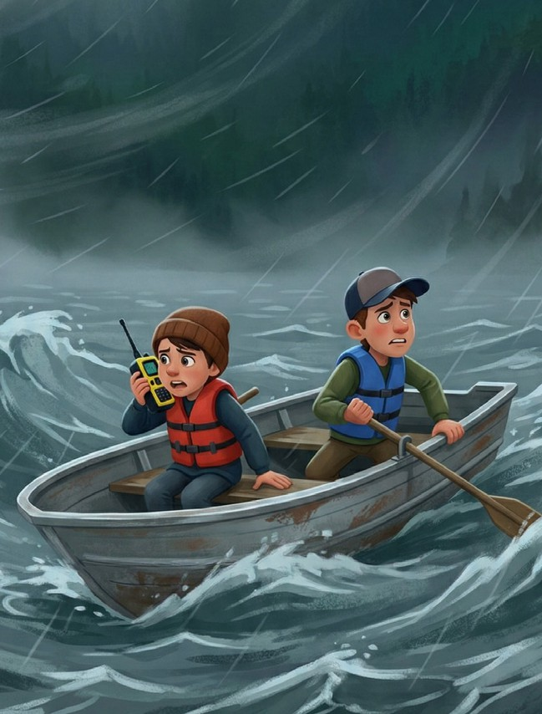
Last summer, Alex and Tom decided to go fishing on Blue Lake. They had prepared their equipment and started their trip early in the morning. At first, the weather was calm and the lake looked peaceful.
However, in the afternoon, dark clouds suddenly appeared and a strong storm began. The wind pushed their small boat far away from the shore. Soon, they realized they had lost their direction in the middle of the lake.
Fear started to grow, but Alex remembered the emergency radio on the boat. He quickly turned it on and sent a signal for help. Meanwhile, Tom tried to keep the boat steady in the rough water.
Fortunately, the coast guard received their message and started a rescue operation. After nearly two hours, the rescue team located the boat and safely brought the two friends back to shore.

Setting | Time | Characters | Atmosphere | Climax
1. | 2. | 3. | 4. | 5.

- Read the text about the hotel fire. Based on the clues provided, find and list the exact word used in the text. (K.E12.7.R1)

Last night, a large fire broke out in a historic hotel downtown. As the flames began to spread, firefighters rushed to the scene. First, the rescue teams managed to evacuate all the guests from the burning building. Fortunately, everyone survived the terrifying event without any serious injuries.
After the fire was put out, the police questioned several witnesses to understand exactly what had happened. Investigators are suspicious that an old heater in the basement caused the fire. Although the exact cost of the damage is still unknown, the estimated loss is over two million dollars. People in the town consider it a true miracle that no lives were lost.
- Clue: Stayed alive after a dangerous event. ..................................

- Clue: Feeling that something is wrong or caused by someone on purpose. ..................................

- Clue: To safely move people out of a dangerous building or place. ..................................

- Clue: A wonderful or amazing event that is very hard to believe. ..................................

- Clue: People who see an accident or event happen and can tell others about it. ..................................

- Read the news story below. Then, number the statements (1-5) to put them in the correct chronological order. (K.E12.7.R2)
Your Local News Source
TOWN NEWS
Monday, September 14, 2026
BREAKING NEWS
SCHOOL FESTIVAL BRINGS JOY TO STUDENTS
Yesterday afternoon, Greenwood High School organized its annual spring festival in the school garden. The event attracted hundreds of students, parents, and teachers.
The festival began at 2:00 PM when the school principal opened the event with a short welcome speech. First, students from the music club performed several popular songs on the stage. Then, the drama club presented a short comedy play that made the audience laugh.
Meanwhile, visitors walked around the school yard and tried food from different stands prepared by students and teachers. Later, the sports club organized fun games and competitions for the students.
In the end, the festival finished with a colorful dance show by the senior students. Everyone enjoyed the lively atmosphere and the school community celebrated a successful day together.

  - Students from the music club performed songs on the stage.
  - The school principal opened the festival with a speech.
  - The drama club performed a comedy play.
  - The festival ended with a dance performance by senior students.
  - Visitors tried food and participated in fun games.

- Read the sentences about the opening of the new city library. Then, write the numbers (1–5) in the boxes to arrange the events in the correct chronological order. (E12.7.R2)
a. Visitors explored the reading halls and borrowed their first books.
b. The city mayor cut the ribbon during the opening ceremony.
c. The construction of the modern library building finished last month.
d. Many students and families attended the opening event.
e. Later, officials announced new cultural programs for the community.

- Read the sentences about a football match carefully. Then, write the numbers (1–5) in the boxes to arrange the events in the correct chronological order. (E12.7.R2)
a. The referee blew the final whistle, and the home team won the match.
b. The players entered the field while the fans cheered loudly.
c. Yesterday evening, an exciting football match took place at the city stadium.
d. In the second half, the home team scored the winning goal.
e. Before the match started, hundreds of fans filled the stadium to support their teams.

- Read the news below and paraphrase it in at least two sentences. (K.E12.7.W1)

WALKING MAKES YOU HAPPIER
A new study shows that walking in a park can greatly improve your mood. Scientists discovered that people who take a short walk every day feel less stressed and more relaxed.
Because of this, health experts suggest that everyone should spend a little more time outdoors.
THE DAILY WELLBEING
……………………………………….......................................................................................................……

…………………………………….......................................................................................................………

- Read the news below and paraphrase it in at least two sentences. (K.E12.7.W1)

HEALTHY BREAKFAST IMPROVES FOCUS
A recent health study shows that eating breakfast helps students do much better in school. Researchers found that kids who eat a morning meal have more energy and pay better attention in class. Because of this, doctors advise parents to make sure their children eat before leaving the house.
THE DAILY WELLBEING
……………………………………….......................................................................................................……

…………………………………….......................................................................................................………

- Imagine that you are a travel blogger. Write at least 4 sentences about a place you visited last summer by answering the questions below. (K.E12.7.W2)

- Who did you go with?
- Where did you go?
- When did you go there?
- How did you feel?
- What did you do there?
- How long did you stay there?
- How did you travel there?
- Where did you stay?
- How was the weather?
- What did you eat?

WELCOME TO MY TRAVEL BLOG

