2025-2026 Anatolian High School 12th Grade 2nd Term 1st Written Exam
Name – Surname: Class: Number:

- Read the brochure and answer the questions. (3x10=30)


“Plant Today, Breathe Tomorrow”

Green Future Association is an environmental nonprofit organization founded in 2015 in İzmir. The association works to fight climate
change and increase public awareness about environmental protection.

The organization invites everyone to join their Tree Planting Campaign on April 18th at 10:00
a.m. at İnciraltı City Park.
The aim of the campaign is to plant 5,000 trees in one day.

DONATE & SUPPORT

All donations will be used for purchasing seedlings.

- What is the aim of the campaign? .....................................................................................................
- Where was the association founded? ...............................................................................................
- What will donations be used for? .......................................................................................................

- Read the scholarship announcement and write an email in response to it. (At least 5 sentences) (5x4=20)

In your email:
  - Introduce yourself (name, field of study).
  - Explain why you are writing.
  - Mention your academic success.
  - Explain why you need the scholarship.
  - Say why you are a suitable candidate.
  - End your email politely.
Dear Sir/Madam,

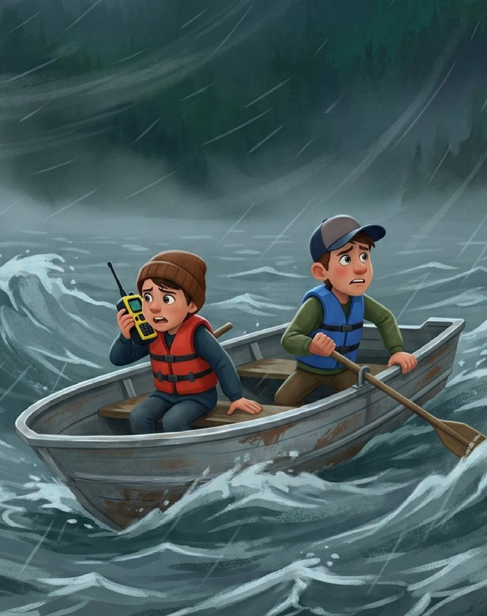
- Read the short story and complete the table. (5x5=25) The Lost Boat
Last summer, Alex and Tom decided to go fishing on Blue Lake. They had prepared their equipment and started their trip early in the morning. At first, the weather was calm and the lake looked peaceful.
However, in the afternoon, dark clouds suddenly appeared and a strong storm began. The wind pushed their small boat far away from the shore. Soon, they realized they had lost their direction in the middle of the lake.
Fear started to grow, but Alex remembered the emergency radio on the boat. He quickly turned it on and sent a signal for help. Meanwhile, Tom tried to keep the boat steady in the rough water.
Fortunately, the coast guard received their message and started a rescue operation. After nearly two hours, the rescue team located the boat and safely brought the two friends back to shore.

Setting | Time | Characters | Atmosphere | Climax
1. | 2. | 3. | 4. | 5.

- Read the news story below. Then, number the statements (1-5) to put them in the correct chronological order. (5x5=25)
Your Local News Source
TOWN NEWS
Monday, September 14, 2026
BREAKING NEWS
SCHOOL FESTIVAL BRINGS JOY TO STUDENTS
Yesterday afternoon, Greenwood High School organized its annual spring festival in the school garden. The event attracted hundreds of students, parents, and teachers.
The festival began at 2:00 PM when the school principal opened the event with a short welcome speech. First, students from the music club performed several popular songs on the stage. Then, the drama club presented a short comedy play that made the audience laugh.
Meanwhile, visitors walked around the school yard and tried food from different stands prepared by students and teachers. Later, the sports club organized fun games and competitions for the students.
In the end, the festival finished with a colorful dance show by the senior students. Everyone enjoyed the lively atmosphere and the school community celebrated a successful day together.

- Students from the music club performed songs on the stage.
- The school principal opened the festival with a speech.
- The drama club performed a comedy play.
- The festival ended with a dance performance by senior students.
- Visitors tried food and participated in fun games.

