2025-2026 Anatolian High School 12th Grade 2nd Term 1st Written Exam
Name – Surname: Class: Number:

- Read the brochure and complete the phrases with the correct details. (4x5=20)


“Plant Today, Breathe Tomorrow”

Green Future Association is an environmental nonprofit organization founded in 2015 in İzmir. The association works to fight climate
change and increase public awareness about environmental protection.

The organization invites everyone to join their Tree Planting Campaign on April 18th at 10:00
a.m. at İnciraltı City Park.
The aim of the campaign is to plant 5,000 trees in one day.

DONATE & SUPPORT

All donations will be used for purchasing seedlings.

- Foundation year : .................................
- Campaign date : ..................................
- Venue : ................................................
- Motto: ..................................................

- Read the text about the hotel fire. Based on the clues provided, find and list the exact word used in the text. (5x4=20)
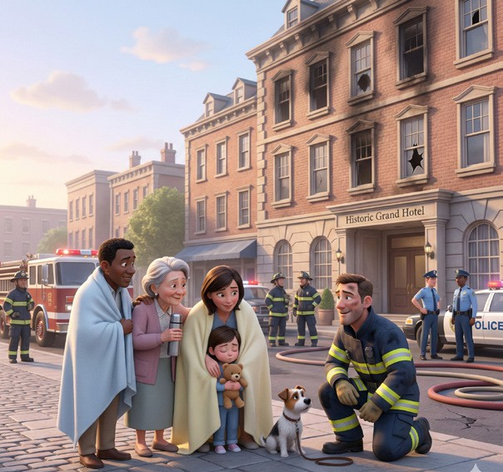
Last night, a large fire broke out in a historic hotel downtown. As the flames began to spread, firefighters rushed to the scene. First, the rescue teams managed to evacuate all the guests from the burning building. Fortunately, everyone survived the terrifying event without any serious injuries.
After the fire was put out, the police questioned several witnesses to understand exactly what had happened. Investigators are suspicious that an old heater in the basement caused the fire. Although the exact cost of the damage is still unknown, the estimated loss is over two million dollars. People in the town consider it a true miracle that no lives were lost.

- Clue: Stayed alive after a dangerous event. ..................................
- Clue: Feeling that something is wrong or caused by someone on purpose. ..................................
- Clue: To safely move people out of a dangerous building or place. ..................................
- Clue: A wonderful or amazing event that is very hard to believe. ..................................
- Clue: People who see an accident or event happen and can tell others about it. ..................................

- Imagine that you are a member of a charity organization for animal rights. Complete the blanks to invite people to an event of your charity organization. Write 5 piece of information. (5x4=20)



Join Us to .....................................................
Aim of the event: .........................................
.......................................................................

You can contribute by:
- ......................................................
- ......................................................

Date: ...........................................

Place: .........................................

............................................................

- Read the sentences about a football match carefully. Then, write the numbers (1–5) in the boxes to arrange the events in the correct chronological order. (5x4=20)
a. The referee blew the final whistle, and the home team won the match.
b. The players entered the field while the fans cheered loudly.
c. Yesterday evening, an exciting football match took place at the city stadium.
d. In the second half, the home team scored the winning goal.
e. Before the match started, hundreds of fans filled the stadium to support their teams.

- Read the news below and paraphrase it in at least two sentences. (2x10=20)
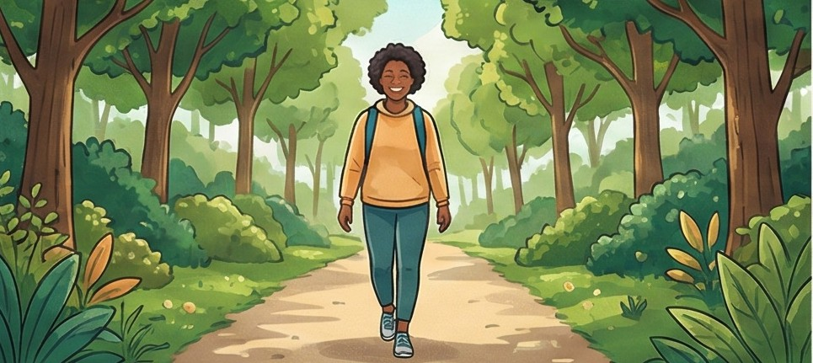
WALKING MAKES YOU HAPPIER
A new study shows that walking in a park can greatly improve your mood. Scientists discovered that people who take a short walk every day feel less stressed and more relaxed.
Because of this, health experts suggest that everyone should spend a little more time outdoors.
THE DAILY WELLBEING
……………………………………….......................................................................................................……

…………………………………….......................................................................................................………

