
Osmaniye Mesleki ve Teknik Anadolu Lisesi 10.Sınıf Sorumluluk Dinleme Sınavı
Name – Surname: Class: Number:

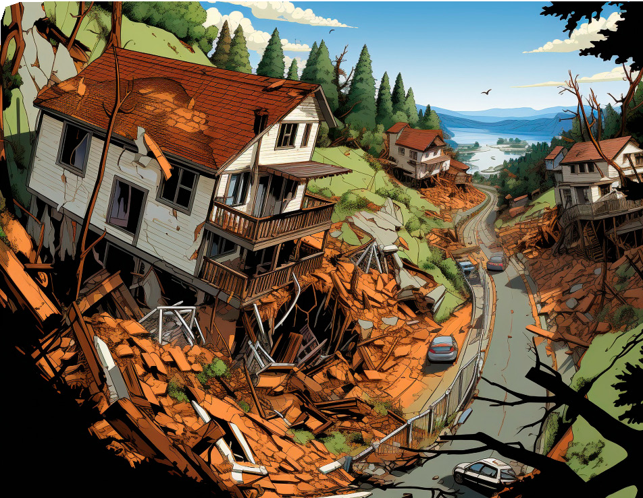

Listening 1 - Listen to the recording and answer the question. Tick ( ) the correct picture. What are the speakers talking about? (1x25=25)

Listening 2 - Listen to the recording again and put the sentences in the correct order. (5x15=75)

Technology is developing day by day.
Social media teenagers stay connected.
Social media makes people less social.
Social media helps us discover new ideas.
Social media wastes a lot of our time.

