Osmaniye Mesleki ve Teknik Anadolu Lisesi 10.Sınıf Sorumluluk Sınavı

- Answer the questions about yourself. (K.E10.1.W1.) (8x2=16pts)

- How old are you?

......................................................................................

- Where do you live?

......................................................................................

- Have you got any brothers or sisters?

......................................................................................

- How do you come to school?

......................................................................................
- Which school subject do you like most?

......................................................................................

- What time do you get up on weekdays?

......................................................................................

- What kind of music do you like?

......................................................................................

- What do you usually do after school?

......................................................................................

- Read the text and answer the questions. (K.E10.3.R2.) (4x5=20pts)
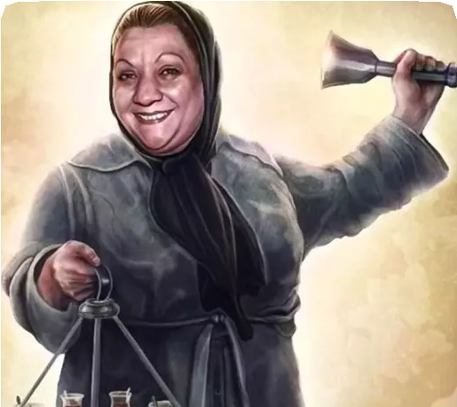
Adile Naşit was a Turkish actress. She was born on 17 June 1930, in İstanbul. She was the daughter of Turkish comedian Naşit Özcan.
She got married twice and had one child. Her son passed away at the age of 12 because of a disease.
She was best known for her movies with another brilliant artist Münir Özkul. She received 6 special awards for her artistic performances in movies and theatre plays. She grew up in İstanbul and lived there. She died of colon cancer on 11 December 1987, in İstanbul.

  - Where was she born?

......................................................................................

  - How many children did she have?

......................................................................................
  - How old was her son when he died?

......................................................................................

  - Why did she die?

......................................................................................

- Read the texts about different festivals all around the world and complete the table. (K.E10.7.R2.) (5x4=20)
Chinese New Year is the most popular festival in China. All the streets and buildings are decorated in red during the celebrations. People perform dragon and lion dances in streets. They eat various traditional dishes like Peking duck. Many tourists come to our country for this festival. It’s fascinating.
My favorite festival is Cinco de Mayo in Mexico. At this festival, red, white, and green clothes are worn. All the streets are decorated with balloons and flowers. We listen to music and perform our folk dances. We eat traditional dishes like tacos. We watch fireworks displays. We have a great time during the celebrations.

Chen

Marla

 | Country | Festival Name | Festival Food
Chen | China | 1. | 2.
Marla | 3. | 4. | 5.

- Imagine that these are your plans for the next week. Write 5 negative or positive sentences about your plans. (K.E10.2.W1.) (5x4=20pts)
Your Next Week Activities
go to the library | 
finish my project | 
meet Pelin after school
study for the exam
join Sevgi’s party
go online
clean my room
go to the camp

  - .................................................................................................

  - .................................................................................................

  - .................................................................................................

  - .................................................................................................

  - .................................................................................................

- Read the texts and answer the question. (K.E10.5.R2.) (6x4=24)
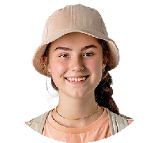




We swam every day, played volleyball on the sand, and enjoyed the sunshine. It was so relaxing.
Emma

We slept in tents near a lake, walked in the
forest, and climbed hills. It was full of adventure!
Jack

Olivia
I visited old buildings, museums, and historical places. I learned many things about the past.

We played in the snow, went skiing, and drank hot chocolate by the fireplace.
Paul



Who talks about...?

Leo
We stayed on a farm, fed the animals, and picked fresh fruits and vegetables. It was peaceful and fun.

Sophia
We traveled on a big ship, visited different countries, and enjoyed the sea view from our cabin. It was amazing!

  - a holiday in the countryside .................................
  - a cultural holiday .................................
  - a beach holiday .................................
  - a winter holiday .................................
  - a camping holiday .................................
  - a cruise holiday .................................

